**INTRODUCTION**

**1.1 INTRODUCTION**

The automotive industry is witnessing a transformative shift fueled by technological advancements and an ever-expanding array of car models. As consumers face the daunting task of navigating through an abundance of options, the need for a more personalized and user-centric approach to car recommendations becomes increasingly evident. This project introduces a state-of-the-art Personalized Car Recommendation System, leveraging the power of machine learning to streamline the car selection process for users. In the era of artificial intelligence, recommendation systems have become integral to enhancing user experiences across various domains. In the context of the automotive sector, the Personalized Car Recommendation System aims to revolutionize the way users explore and choose their vehicles. By harnessing the capabilities of machine learning algorithms, this system tailors recommendations based on individual preferences, providing users with a curated list of cars that align with their unique needs and desires.

The project is motivated by the desire to bridge the gap between the abundance of available car models and the personalized preferences of consumers. The Car Rental System is the online facility to book cars online within few clicks only. Some people cannot afford having a car, for those people this system becomes very helpful. This system includes various cars, as per the customer order and comfort, it place the order and deliver the car as per the location within the area. For travelling a long distance, booking can be done via internet service only. By working on this project, we delve into the heart of the technological evolution driving the automotive sector and contribute to the ongoing advancements in personalized recommendations. This project encompasses the integration of multiple disciplines, including machine learning, data science, and software engineering.

Furthermore, the project emphasizes a user-centric design approach, recognizing the importance of prioritizing user satisfaction and engagement. In the subsequent phases of the project, we will delve into the hands-on implementation of machine learning algorithms, working with real-world data sets related to cars, user preferences, and reviews. Through data preprocessing, analysis, and feature engineering, we strive to develop a robust and adaptive recommendation system capable of learning and evolving with user interactions. This project represents an opportunity for innovation, problem-solving, and meaningful contributions to the intersection of artificial intelligence and automotive retail.

**Advantages of AutoRecs**

Implementing a personalized car recommendation system, such as AutoRecs, offers several advantages that significantly enhance the car rental experience for both service providers and customers:

i.Personalized Recommendations: One of the primary benefits of AutoRecs is its ability to provide personalized vehicle recommendations based on individual customer preferences, historical rental data, and current market trends. By analyzing factors like preferred vehicle types, budget constraints, and rental history, the system can suggest vehicles that align closely with each customer’s unique needs and expectations. This personalization not only improves customer satisfaction by offering tailored solutions but also increases the likelihood of selecting a vehicle that meets all requirements, enhancing overall rental experience.

ii. Dynamic Pricing Optimization: AutoRecs can optimize pricing dynamically based on various factors such as demand patterns, seasonal fluctuations, and competitor pricing. By analyzing real-time market data and customer behavior, the system can adjust rental rates accordingly to maximize revenue while remaining competitive. This capability ensures that pricing remains flexible and responsive, attracting price-sensitive customers during off-peak periods and maximizing profitability during peak times.

iii. Up-selling Opportunities: The system can identify up-selling opportunities by recommending higher-category vehicles or additional services based on customer preferences and budget considerations. By presenting relevant up-selling options during the booking process, AutoRecs enhances revenue potential for rental service providers while providing customers with choices that may better suit their needs or preferences.

iv. Customer Loyalty and Retention: Through consistent delivery of personalized recommendations and superior customer service, AutoRecs fosters stronger customer loyalty and retention. By continuously meeting and exceeding customer expectations, the system encourages repeat business and positive word-of-mouth referrals. This loyalty-building aspect is crucial in a competitive rental market, where customer satisfaction and retention directly impact long-term profitability and market share.

v. Reduced Decision Fatigue: AutoRecs reduces decision fatigue by simplifying the car selection process for customers. Instead of overwhelming customers with a vast array of options, the system narrows down choices to a curated selection that best matches their preferences and requirements. This streamlined approach saves time and effort for customers, resulting in a more efficient and satisfying rental experience.

vi. Customer Education: The system serves as an educational tool by providing information about vehicle features, rental policies, and optional extras during the booking process.

Implementing AutoRecs in a car rental service contributes to operational efficiency, enhances customer satisfaction, and drives revenue growth through personalized recommendations, dynamic pricing, up-selling opportunities, and customer loyalty initiatives. By leveraging advanced technology and data-driven insights, AutoRecs transforms the rental experience into a seamless, personalized journey that benefits both customers and service providers alike.

#### 1.2 NECESSITY

The implementation of a Personalized Vehicle Recommendation System is crucial in addressing the complexities and challenges that consumers face in the contemporary automotive landscape. With an ever- expanding array of car models and features, the traditional approach to car selection has become overwhelming for individuals. The necessity of a personalized recommendation system lies in its capacity to streamline and enhance the entire car- buying experience. By leveraging advanced machine learning algorithms, this system considers individual preferences, driving habits, budget constraints, and specific feature requirements to deliver tailored recommendations.

In addition to simplifying the decision-making process, a Personalized Vehicle Recommendation System contributes to informed choices. By analyzing user data and interactions, the system provides valuable insights into various car models, empowering consumers with comprehensive information about the features, performance, and suitability of different vehicles. This personalized approach not only ensures that users find cars that align with their unique needs but also fosters a sense of confidence and satisfaction in their decision-making.

Moreover, the system aligns with the contemporary demand for personalized and user-centric experiences. In an era where consumers expect tailored solutions across various domains, a Personalized Vehicle Recommendation System meets these expectations in the automotive sector. This not only improves user satisfaction but also promotes engagement and a positive connection between consumers and the car-buying process.

In the contemporary automotive landscape, the necessity of a Personalized Vehicle Recommendation System is evident, addressing the challenges posed by the vast array of available car models and the evolving preferences. This individualization is crucial, given that every car buyer has unique criteria and priorities, such as fuel efficiency, safety features, which a one-size-fits-all approach cannot adequately address.

This time efficiency is particularly valuable for busy consumers who seek a streamlined and efficient car-buying process. From a business perspective, personalized recommendation systems offer advantages such as improved conversion rates and increased user retention. Users are more likely to trust and engage with a platform that understands and caters to their specific needs, creating a positive feedback loop that benefits both consumers and automotive retailers.

**How it is useful?**

The necessity of personalized car recommendation systems is rooted in their ability to significantly improve the car rental experience for users and deliver various benefits for both customers and service providers. By tailoring recommendations to individual preferences, these systems ensure that users can efficiently find cars that align with their specific needs and preferences, leading to higher satisfaction and an overall positive user experience. An existence system has several problems in the working procedure for the organization and customers.

During car reservation the customer reserves a vehicle by making a phone call to the organization otherwise, he/she is expected to go to the organization to make a reservation. This might result in a waste of money, time and energy of the customer. It may be difficult for the customer to find the address or phone number of the organization. The organization cannot handle the customers 24/7. As it presently works only for working hours. During renting a car the customer’s personal information, payments status and rent agreements are filled in the car rent agreement form in order to hold legal contract between the customer and organization for renting the vehicle. It may be difficult to find in case of lost or misplaced document

The system ensures that users are presented with cars that align with their specific criteria, whether it's size, fuel efficiency, or certain features. Additionally, the consistency of recommendations across various platforms provides a seamless rental experience. Personalized promotions, discounts, and loyalty rewards further enhance user satisfaction and offer added value. The system adapts to changing preferences over time, fostering a trusting relationship between users and the recommendation platform.

**1.3 SYSTEM REQUIREMENTS**

**1.3.1 Hardware Requirements**

|  |  |
| --- | --- |
| Processor | A multi-core CPU ( Intel Core i5 or AMD Ryzen 5) with 4 cores or more for multitasking and managing project tasks. |
| RAM | 8 GB DDR4 or higher. |
| Secondary storage | SSD (Solid-State Drive) with at least 50 GB of storage capacity and NVMe SSD for faster data access. |

* + 1. **Software Requirements**

|  |  |
| --- | --- |
| Deep learning frameworks | Flask, Random Forest, SciKit Learn |
| IDE | Anaconda Navigator, VS Code, Kaggle, GoogleColab |
| Programming language | Python, PHP |
| Dataset | Web scrapping, manually collected data |

**PROBLEM STATEMENT**

The primary aim of this research is to revolutionize the car-buying experience by introducing a sophisticated Vehicle Recommendation System (CRS) based on machine learning technologies and to ease customer’s task whenever they need to rent a car. The system aims to prioritize user preferences, providing personalized recommendations and addressing the challenges associated with conventional vehicle consultancy

### 1.3 OBJECTIVE

* Review State-of-the-Art: Conduct an in-depth review of existing Vehicle recommendation systems, with a focus on approaches incorporating user preferences and car features.
* Identify Challenges: The purpose of the project is to build an application program to reduce the manual work for managing the Car, Car Company, Payment, Car Type. It tracks all the details about the Car Type, Booking, Customer.
* Develop Novel CRS: Design and implement a novel Vehicle Recommendation System that leverages machine learning, incorporating user preferences, historical data, and vehicle specifications to offer personalized recommendations.
* Evaluate Popular Algorithms: Assess the performance of two widely used algorithms, Random Forest and K-means clustering, in the context of Vehicle recommendation.

### 1.4 MOTIVATION

The project's potential for impact is profound, recognizing its capacity to reshape how users explore and choose vehicles, ultimately influencing the automotive retail experience. As a final year project, it serves as a preparation ground, equipping students with the skills and experiences needed to tackle similar challenges in their future endeavours.

One of the project's key motivations lies in the integration of multiple disciplines. By combining skills from various fields, including machine learning and software engineering, students can showcase integrating technologies to address complex problems.

This alignment allows students to gain insights and contribute to an industry undergoing advancements, particularly in the realm of personalized recommendations.

### 2. LITERATURE SURVEY

|  |  |  |  |  |  |  |
| --- | --- | --- | --- | --- | --- | --- |
| Sr.  no | Paper name | Author Names | Algorithm/  Method | Result/  Accuracy | Advanta-ge | Disadvantage |
| 1. | Personalized Recommendat ion Systems (PRES): A  Comprehensivee Study and Research. Issues. (2018) | Mr. Raghavendra CK, Dr. Srikantaiah K. C, Venugopal K.R | Hybrid filtering Techniques, Collaborati ve filtering system (CF), Content- based filtering | It highlight trade-offs between complexity, interpretability, personalization, and computational resources | Hybrid filtering techniques lie in their ability to enhance recommendati on accuracy. | The setback of the CBF technique is a failure to appraise the value of an item as it cannot differentiate quality documents from the poor when both denoted with the terms. |
| 2. | A Method of Personalized Driving Decision for Smart Car Based on Deep Reinforcement Learning (2020) | Xin peng Wang 1, Chaozhong Wu 1, Jie Xue 1,2 and Zhijun Chen 1 | Reinforcem ent Learning, Determinist ic Policy Gradient (DPG) | 78% | A personalized driving decision model is built based on the decision- making self- learning ability. | It is crucial to ensuring the safety, reliability, and ethical implications of such systems in real-world driving scenarios. |
| 3. | Exploring  PersonalizedAutonomous Vehicles to Influence User Trust (2020) | Xu Sun  &Jingpeng Li  &Pinyan Tang  & Siyuan Zhou  &  Xiangjun  Peng &Hao  Nan Li  &QingfengWang | Hybrid filtering Techniques, Collaborati ve filtering system (CF), Content- based filtering | 75% | AVs have proved successful in convoy situations and have demonstrated the ability to improve the maintenance of a consistent safe distance and emergency stopping distances compared with non- automated systems. | It is difficult to ensure that drivers in the driving simulator will behave as they would in the real world. |
| 4. | Car Recommendation System Using Customer Reviews (2022) | Saumya Singh, Soumya deepta Das, Ananya Sajwan, Ishanika Singh, Ashish Alok | Collaborative filtering | 93% | Integrating the machine learning notebook with the Flask application to create a fully functional product, multiple testing scenarios and removing bugs which improved the accuracy and the efficiency of the recommender system. | Many customer can give false review and that review becomes the obstacle for the recommender system. |
| 5. | Enhancement of Mobile-Based Application for Vehicle Rental (2021) | Falah Y H Ahmed, Eizwan Bin Hazlan, Muhammad Irsyad Abdulla | Knowledge- based model, agile approach | The accuracy depends on the vehicle availability. | It can lead to a system that is not only informed by explicit knowledge but also agile and responsive to user needs and industry changes. | There is no particular disadvantage but 0.5% error is there as a disadvantage. |
| 6. | Smart Recommendation System based on Product Reviews using Random Forest (2019) | Gayatri Khanvilkar, Prof. Deepali Vora | Decision tree, Random Forest, Naive Bayes algorithm, SVM Classifier | 95.03% | It can focus on interpretability, efficiency, handling non- linearity, and scalability of the system. | Sometimes, the specific context and implementation details of the system product review is not provide the essential information. |
| 7. | Recommendations for Car Selection System Using Item- Based Collaborative Filtering (CF) (2019) | Gusti Prabowol, 2019 Muhammad Nasrun, Ratna Astuti Nugrahaeni | Item-based Collaborative Filtering, Collaborative Filtering algorithm | 95.955% | It increases the scalability and flexibility of the system. | It can arise the privacy concern for the user. I Recommending items for new users, who have not provided sufficient interactions, can be challenging |
| 8. | Car Recommendatio In System for Dealers in Different European Countries (2022) | Sixiang Cheng, Tianyu Wang | Collaborative filtering (CF)method | 92% | It can recommend items according to the historical information of each user, which has nothing to do with the content attributes of the item itself, which is the reason why we choose CF as our model to develop the recommendatio In system. | It may involve exploring hybrid recommendation approaches that incorporate content- based filtering. considering regional factors in the recommendation algorithm, and implementing robust privacy measures to ensure compliance with data protection regulations. |
| 9. | Personalized Car Recommendatio- ns Using Knowledge- Based Methods (2023) | Reham Alabduljabbar, Maha Alghamdi, Hala Alshamlan | Knowledge- based recommender approach, collaborative filtering method | 89% | It provides an effective and personalized solution to the car selection process, making it easier for users to find the cars that best match their preferences and needs. | The deal between the interpretability of rule-based systems and the adaptability of collaborative filtering. |
| 10. | Vehicle  Recommendatio n System using Hybrid Recommender Algorithm and Natural Language Processing Approach (2019) | Pubudu Boteju, Lankeshwara Munasinghe | Hybrid recommender algorithm, algorithm,Multiclass neural network,multiclass random  Algorithm  preferences and needs. | 96% | It ensures the diversity, simplicity, and robustness of the system. | It highlight trade-offs between complexity, interpretability, personalization, and computational resources |
| 11 | Personalized Car Recommendations Using Knowledge-Based Methods  (2023) | Reham  Alabduljabbar,  Maha Alghamdi,  Hala Alshamlan | Hybrid Recommender Algorithm and Natural Language | 89% | It provides an effective and personalized solution to the car selection  process, making it easier  for users to find the cars that best match their preferences and needs. | The deal between the interpretability of rule-based systems and the  adaptability of collaborative filtering |

**3.SYSTEM DEVELOPMENT**

**3.1 TECHNOLOGIES WE USED**

**3.1.1 Python**

Python is a versatile and high-level programming language known for its readability and ease of use. It supports multiple programming paradigms, making it suitable for various applications. Python’s extensive standard library and a rich ecosystem of third-party packages make it a popular choice for web development, data science, machine learning, automation, and more. Itssimplicity and community support contribute to rapid development and efficient problem-solving in diverse projects.

**3.1.2 Random Forest Algorithm**

The Random Forest algorithm is a versatile and powerful machine learning ensemble method commonly employed for both classification and regression tasks. It operates by constructing an ensemble, or a multitude, of decision trees during the training phase. Each decision tree is grown using a bootstrap sample, a random sample with replacement drawn from the training dataset.The strength of the Random Forest algorithm lies in its ability to mitigate over fitting and enhance generalization by leveraging the diversity among individual trees. Additionally, it addresses the importance of feature selection and captures complex relationships within the data. One of the notable features of Random Forest is its applicability to large datasets with high dimensionality, making it a popular choice across various domains.

**Random Forests**

Random forests (RF) construct many individual decision trees at training. Predictions from all trees are pooled to make the final prediction; the mode of the classes for classification or the mean prediction for regression. As they use a collection of results to make a final decision, they are referred to as Ensemble techniques.

### Feature Importance

Feature importance is calculated as the decrease in node impurity weighted by the probability of reaching that node. The node probability can be calculated by the number of samples that reach the node, divided by the total number of samples. The higher the value, the more important the feature.

**Implementation in Scikit-learn**

For each decision tree, Scikit-learn calculates a node's importance using Gini Importance, assuming only two child nodes (binary tree):

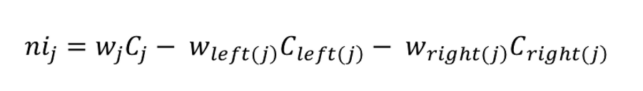

${ni}_{j}$ $= the importance of node j$

$w_{j}​ = weighted number of samples reaching node j$

$C_{j}​ = the impurity value of node jj$

$left(j) = child node from the left split on node j$

$right(j)= child node from the right split on node j$

* ​

The importance for each feature on a decision tree is then calculated as:



${fi}_{i}​ = the importance of feature i$

${ni}_{j}= the importance of node j$

These can then be normalized to a value between 0 and 1 by dividing by the sum of all feature importance values.



The final feature importance, at the Random Forest level, is its average over all the trees. The sum of the feature’s importance value on each tree is calculated and divided by the total number of trees:



${RFfi}_{i}​= the importance of feature ii calculated from all trees in the$

$Random Forest model$

${normfi}_{ij}​ = the normalized feature importance for i in tree j$

$T = total number of trees$

To calculate the final feature importance at the Random Forest level, first, the feature importance for each tree is normalized in relation to the tree:



${normfi}_{i}= the normalized importance of feature i$

${fi}_{i}​ = the importance of feature i$

Then feature importance values from each tree are summed normalized:



${RFfi}_{i}​= the importance of feature ii calculated from all trees in the Random Forest model$

${normfi}_{ij}= the normalized feature importance for ii in tree jj$

**3.1.3 Flask**

Flask is a web framework for Python, designed to make it easy to build web applications. It is lightweight and follows the WSGI (Web Server Gateway Interface) standard. Flask provides a simple and flexible way to create web applications and APIs.

**3.1.4 Pandas**

Pandas is a powerful data manipulation and analysis library for Python. It provides data structures like Data Frame, which is especially useful for handling and processing structured data. Pandas is widely used in data science and analytics.

**3.1.5 Scikit-learn (sklearn)**

Scikit-learn is a machine learning library for Python. It offers a variety of tools for tasks such as classification, regression, clustering, and dimensionality reduction. Scikit-learn is built on other popular scientific computing libraries like NumPy and SciPy.

**3.1.6 Unsplash**

Unsplash is a platform where photographers share high-resolution images for free. It has a vast library of photos available under the Creative Commons Zero license, allowing free use for personal and commercial projects. The platform is community-driven, offers an API, and has a premium subscription service for additional features.

**3.1.7 Googlesearch (search_images)**

This is a modified version or adaptation of Googlesearch, specifically customized for conducting image searches. It allows users to retrieve images based on specified search criteria, making it useful for applications that involve working with images.

**3.1.8 HTML/CSS**

HTML is the standard markup language for creating web pages. It provides a structure for web content through elements and tags. SS is a stylesheet language used for describing the presentation and layout of HTML documents. It allows developers to control the visual aspects of a web page, including colors, fonts, and spacing.HTML and CSS together form the backbone of web development, ensuring both structure and style in a website

#### 3.2 SYSTEM OVERVIEW

#### 3.2.1 Agile Life Cycle

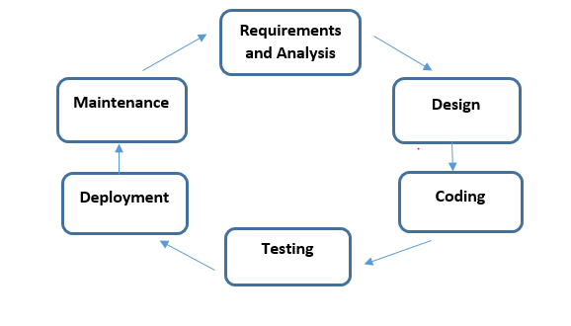

**Fig. 3.2.1 Agile Life cycle for Personalized Vehicle Recommendation System**

The Agile model is an iterative and incremental approach to software development that prioritizes flexibility, collaboration, and continuous delivery. Agile methodology emphasizes the importance of delivering working software frequently, rather than focusing solely on comprehensive documentation or following a strict plan. Agile teams work closely with customers and stakeholders to ensure that their needs are being met, and they prioritize responding to change over following a rigid plan.

The Agile model in software testing is an iterative and incremental approach to software development that emphasizes flexibility, collaboration, and continuous delivery. It is a response to traditional software development methods that were often inflexible, slow to adapt to changing requirements, and heavily focused on documentation.

SDLC agile model values individuals and interactions over processes and tools, and prioritizes responding to change over following a strict plan. This means that Agile teams work closely with customers and stakeholders to ensure that their needs are being met, and they prioritize delivering working software frequently, rather than focusing solely on comprehensive documentation or following a strict plan.

Some popular agile methodologies include Scrum, Kanban, and Extreme Programming (XP).Each methodology has its own set of principles and practices, but they all share a common set of values and a focus on delivering value to customers.

There are agile model phases which are shown below:

**Requirements gathering:**

Objective: Define the features and requirements of the personalized vehicle recommendation system.

Activities: Product Owner collaborates with stakeholders (car dealerships, automotive experts, end-users) to gather detailed requirements. These are documented in the product backlog.

**Planning:**

Objective: Plan sprints and prioritize backlog items based on customer value and feasibility.

Activities: Agile team plans iterations (sprints) typically lasting 1-4 weeks. Features are selected from the backlog and estimated for effort required.

**Design:**

Objective: Design the architecture and user interface for the recommendation system.

Activities: Iterative design process involves creating prototypes, gathering feedback from stakeholders (including potential users), and refining the design based on feedback.

**Development:**

Objective: Incrementally build the vehicle recommendation system based on selected features and designs.

Activities: Development team uses Agile practices like test-driven development (TDD) and continuous integration (CI) to ensure high quality of each increment delivered in every sprint.

**Testing:**

Objective: Verify that each increment meets acceptance criteria and is free of defects.

Activities: Automated and manual testing is conducted throughout the development process to ensure the reliability and functionality of the recommendation system.

**Deployment:**

Objective: Deploy increments of the recommendation system to a production-like environment.

Activities: Incremental deployment allows for continuous integration of new features and ensures that the system is ready for real-world usage after each sprint.

Maintenance: In this phase, the team receives feedback from the product owner and the end-users. The team uses this feedback to improve the product and the process.Monitor system performance and gather user feedback.

In SDLC methodology, Agile model works for software development in such a situation when customer needs change according to the changing needs of the market and they need new changes in the product. This is the most expensive method however with the help of this the developing work can be done very fast and the level of customer satisfaction is also very high as there is an arrangement to add new updates to the software as per the request of every change received from the customer.

**3.2.2 System Architecture**

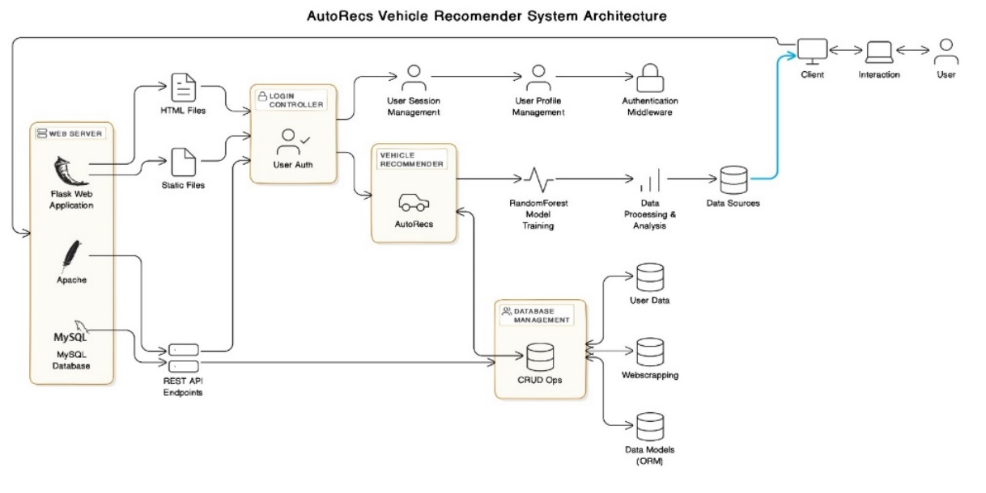

**Fig. 3.2.2 System Architecture Diagram for AutoRecs**

The system Architecture diagram provided represents the workflow of a vehicle recommendation system, detailing the various components and their interactions from user input to the final recommendation display. Here is an explanation of each component and the overall flow:

**1. User Interaction and Authentication:**

* The system starts with user interaction via a web interface.
* Users interact with the client (web browser) and communicate with the server.
* An authentication middleware layer handles user login and authorization.

**2. Data Collection and Processing:**

* **Data Sources:** The system gathers data from various sources, including user data, web scraping, and possibly external APIs.
* **User Data:** The system collects user information (e.g., preferences, demographics) for personalized recommendations.
* **Data Processing:** The system cleans, transforms, and analyzes the collected data for effective use.

**3. Model Training and Recommender Engine:**

* **Random Forest Model:** The system utilizes a Random Forest model for machine learning. This model is trained on the processed data to learn patterns and relationships between user preferences and vehicle characteristics.
* **Vehicle Recommender:** The trained Random Forest model is the core engine for generating personalized vehicle recommendations for users.

**4. System Architecture:**

* **Web Server:** The system employs a Flask Web Application running on an Apache server.
* **REST API Endpoints:** A RESTful API exposes functionality to interact with the system's services (e.g., user authentication, data retrieval, recommendation requests).
* **Database Management:** The system uses a MySQL database for storing user data, models, and other system-related information.
* **CRUD Operations:** The database provides functionalities for creating, reading, updating, and deleting data.

**5. User Interface and Experience:**

* **HTML Files and Static Files:** The web interface of AutoRecs is built with HTML files and static assets.
* **User Session Management:** The system manages user sessions to provide a personalized experience and track user activity.
* **User Profile Management:** Users can manage their profile information and preferences within the system.

**Overall Functionality:**

* When a user interacts with AutoRecs, their preferences and other data are collected.
* This data is processed and used to train the Random Forest model.
* The trained model then generates personalized vehicle recommendations based on the user's input.
* These recommendations are presented to the user via the web interface.

**3.3.3 CLASS DIAGRAM**

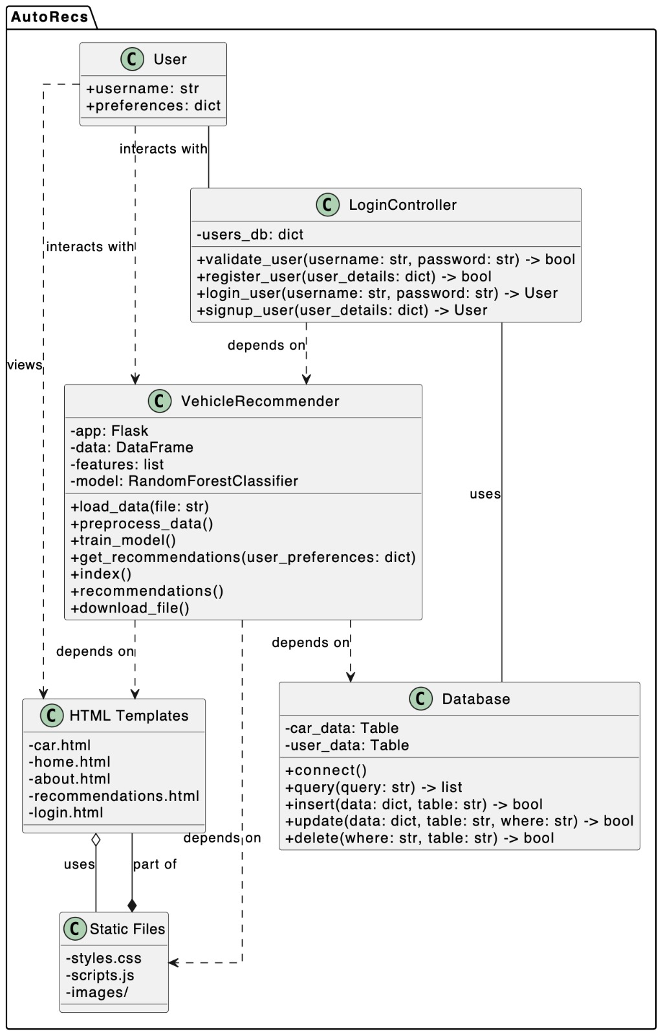

**Fig.3.3 Class Diagram for AutoRecs**

**Class Diagram Overview:**

A class diagram is a visual representation of the structure of a software system using UML (Unified Modeling Language).It shows classes, their attributes (data members), methods (functions), and relationships between classes.

**Key Elements in the Diagram**

1. **Classes**: Represented as rectangles with the class name inside. Classes encapsulate data (attributes) and behavior (methods).
2. **Attributes**: Shown as variables or properties within a class. These represent the state of the object and are often nouns or noun phrases (e.g., app, data, features, model).
3. **Methods**: Represented as functions or operations within a class. Methods define the behavior or actions that objects of the class can perform (e.g., load_data, preprocess_data, train_model, get_recommendations).
4. **Relationships**:

* **Association**: Indicates a connection between classes, often described with a verb or verb phrase (e.g., "User interacts with LoginController").
* **Inheritance**: Depicts a parent-child relationship where one class (child) inherits attributes and methods from another class (parent) (e.g., VehicleRecommender inherits from HTML Templates).
* **Dependency**: Shows that one class depends on another if changes in the latter could affect the former (e.g., a method in one class uses an object of another class as a parameter).

Example Classes and Their Elements

1. **Vehicle Recommender Class**:

* **Attributes**: app (Flask), data (DataFrame), features (list), model (RandomForestClassifier).
* **Methods**: load_data, preprocess_data, train_model, get_recommendations, and more.

1. **Database Class**:

* **Attributes**: car_data (Table), user_data (Table).
* **Methods**: connect, query, insert, update, delete.

When creating a UML class diagram, **Classes** are central each representing a distinct entity or concept in your system. **Attributes** describe the properties or data each class holds. **Methods** define the operations or behaviors that the class can perform. **Relationships** (association, inheritance, dependency) connect classes and illustrate how they interact or depend on each other. UML class diagrams serve as valuable blueprints for designing, documenting, and maintaining complex software systems.

**3.3.4 Use Case Diagram**

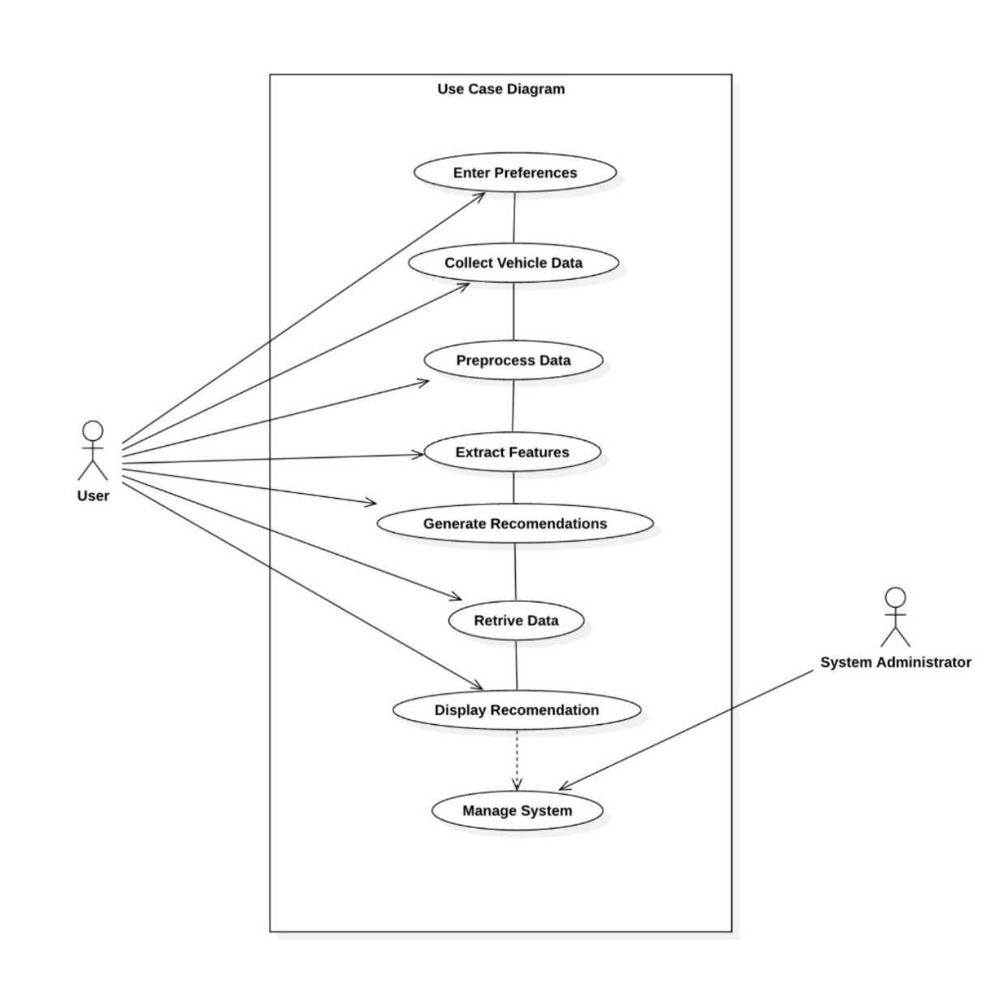

**Fig. 3.3.4 Use Case Diagram for Personalized Vehicle Recommendation System**

**User Interaction System Overview**

**System Description:** **Use Case helps** Defines various interactions between users and the system, illustrating how users interact with different components and functionalities The User Interaction System is designed to facilitate interactions between users and a process that provides personalized vehicle recommendations based on user preferences.

**Diagram Layout:**

* **Users (left side):** Represents individuals interacting with the system to input preferences and receive recommendations.
* **Administrator (right side):** Oversees and manages the system, ensuring its functionality and performance.

**Components:**

* **User:** Initiates actions such as entering preferences and receiving recommendations.
* **System:** Handles processes like data collection, preprocessing, recommendation generation, and retrieval.
* **Administrator:** Manages the system overall, ensuring its smooth operation.
* **Enter Preferences:**
* **User Action:** Users input their preferences related to vehicle features they desire (e.g., fuel efficiency, seating capacity, price range).

**Collect Vehicle Data:**

* **System Action:** Gathers extensive data related to various vehicles available in the system's database or external sources.
* **Preprocess Data:**
* **System Action:** Cleans, organizes, and prepares the collected vehicle data for further analysis and processing.

**Extract Features:**

* **System Action:** Identifies and extracts relevant features from the preprocessed data, such as technical specifications and user ratings.

**Generate Recommendations:**

* **System Action:** Utilizes algorithms and models to create personalized vehicle recommendations based on the user's input preferences and extracted features.

**Retrieve Data:**

* **System Action:** Fetches additional information as needed during the recommendation generation process, ensuring comprehensive and accurate recommendations.

**Display Recommendation:**

* **System Action:** Presents the generated vehicle recommendations to the user in a clear and understandable format through the user interface (UI).

**System Administrator:**

* **Role:** Responsible for managing and overseeing the entire User Interaction System.
* **Responsibilities:** Include system maintenance, performance monitoring, data integrity management, user account management, and configuring system parameters.
* **Connection to "Manage System":** The administrator is linked to the final step of the process, which involves overall system management, ensuring that the system functions efficiently and meets user expectations.

The system administrator plays a crucial role in ensuring the system's operational integrity and efficiency. This structured approach aims to enhance user experience by providing personalized recommendations based on user preferences and system-generated insights.

**3.3.5 DFD diagram with level 0**

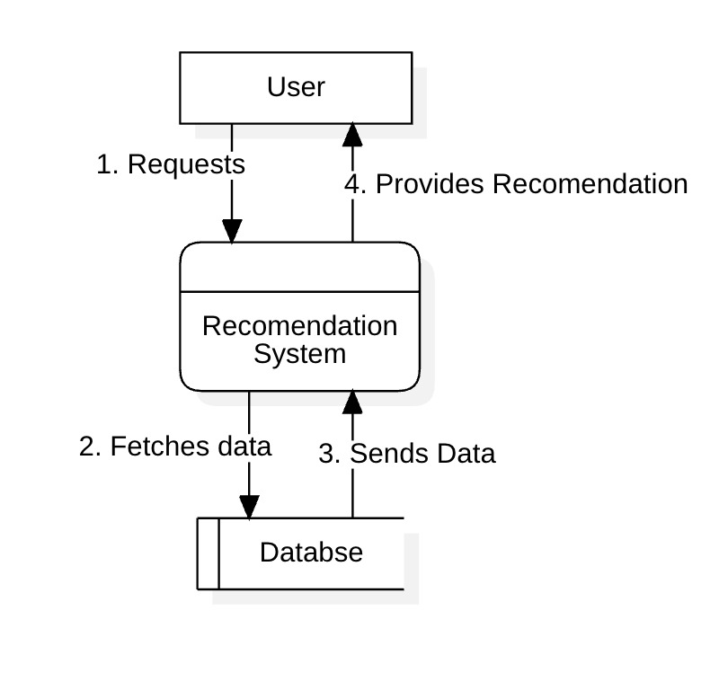

**Fig 3.3.5 DFD diagram for AutoRecs with level 0**

The system involves three main components:

* **User:** Initiates requests for recommendations.
* **Recommendation System:** Processes user requests, retrieves relevant data from the database, generates recommendations, and sends them back to the user.
* **Database:** Stores the data necessary for generating recommendations.

**Key Steps in the Process**

**User Requests:**

1. Description: The process begins with the user initiating requests for recommendations from the Recommendation System.
2. Action: The user specifies their preferences, requirements, or queries related to the recommendations they seek.

**Data Flow - Fetches Data:**

1. Description: Upon receiving the user's request, the Recommendation System fetches relevant data from the Database.
2. Action: This step involves querying the database based on the user's input to retrieve pertinent information needed to generate accurate recommendations.

**Data Exchange - Sends Data:**

1. Description: After retrieving the necessary data from the Database, the Recommendation System sends this data back to the user.
2. Action: The retrieved data may include raw information about products, services, or items relevant to the user's request. This exchange ensures that the user has access to the latest data.

**Recommendation Output - Provides Recommendation:**

1. Description: Finally, the Recommendation System processes the retrieved data to generate tailored recommendations for the user.
2. Action: This step involves applying algorithms, models, or rules to analyze the data fetched from the database. It aims to produce recommendations that best match the user's preferences, needs, or criteria specified during the initial request.

**System Dynamics:**

1. User Interaction: The system is user-driven, meaning that all actions originate from user requests.
2. Data Flow: The flow of information starts with the user's query, progresses through database retrieval by the Recommendation System, and culminates in the delivery of recommendations back to the user.
3. Feedback Loop: Depending on the system's design, there may be mechanisms for user feedback on recommendations provided, which can further refine future recommendations.

This DFD Level 0 System diagram illustrates a streamlined process where a user interacts with a recommendation system that interfaces with a database. It highlights the flow of actions from user requests to data retrieval, processing, and the ultimate delivery of personalized recommendations.

Top of Form

Bottom of Form

* + 1. **DFD diagram with level 1**

A Data Flow Diagram (DFD) Level 1 provides a more detailed view of the processes and data flows depicted in a system compared to a higher-level DFD, such as a Context Diagram or Level 0 DFD,

A DFD Level 1 diagram provides a detailed view of how data moves through processes and data stores within a system. It helps in understanding the flow of information and interactions between different components of the system and external entities.

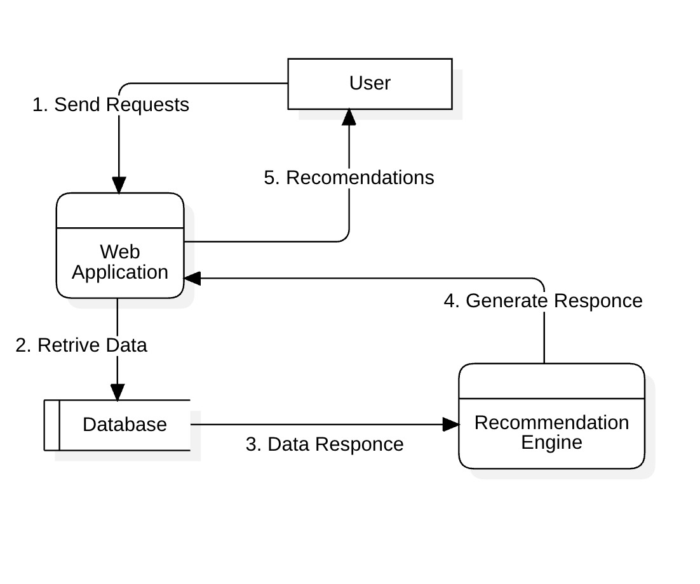

**Fig 3.3.6 DFD diagram for AutoRecs with level 1**

**Components of DFD Level 1**

**External Entity:** User

* Description: Represents people interacting with the web application, such as customers, administrators, or content creators.
* Interactions:

1. Filling out forms (e.g., registration, search forms, product reviews)
2. Clicking buttons (e.g., "Add to Cart," "Submit Order," "Like")
3. Uploading files (e.g., profile pictures, product images)
4. Navigating through the application using menus and links

**Data Flow 1:** Sends Requests

* Description: Shows data sent by the user to the web application.
* Data Types:
  1. Form data: Information entered into fields like username, password, product choices, or search terms.
  2. Button clicks: Specific details about actions triggered by buttons, such as product IDs or search categories.
  3. Uploaded files: Raw data from files like images or documents.
  4. Navigation data: Path taken by the user through the application.

Web Application

* Description: The core part of the web application that processes user requests and generates responses.
* Functions:Request Interpretation: Understands what the user wants (e.g., searching for products, adding items to cart, submitting reviews).

Business Logic Execution: Performs actions based on user requests, like accessing the database (Data Flow 2), calculating costs, or generating content.

Response Generation: Creates responses like web pages, confirmation emails, or updated user accounts.

**Data Flow 2:** Retrieve Data

* Description: Data fetched by the web application from a database or external source.
* Data Examples:
  1. Product details (name, description, price, images) for product-related requests.
  2. Customer information (name, address, order history) for managing accounts or processing orders.
  3. Content (articles, blog posts, forum discussions) for displaying on the application.

Data Store: Database

* Description: Stores all application data in an organized manner for efficient retrieval and management.

**Data Flow 4**: Data Response

* Description: Data sent back to the user from the web application.
* Examples:
  1. Dynamically generated web pages showing products, search results, or personalized content.
  2. Confirmation messages (e.g., order placed, registration complete).
  3. Error messages for invalid inputs or failed actions.
  4. Updates reflected on the user interface (e.g., shopping cart updates, profile details).

Process:

1. Analyzes user data like purchase history or browsing behavior.
2. Applies recommendation algorithms to suggest relevant products, content, or actions.

Users interacting with the web application by sending requests (like filling forms or clicking buttons).The web application processes these requests by interpreting what users want, executing tasks like retrieving data from the database, and generating responses.Data flows illustrate how information (like user inputs or retrieved data) moves between users, the web application, and the database.

* + 1. **Sequence Diagram for AutoRecs**

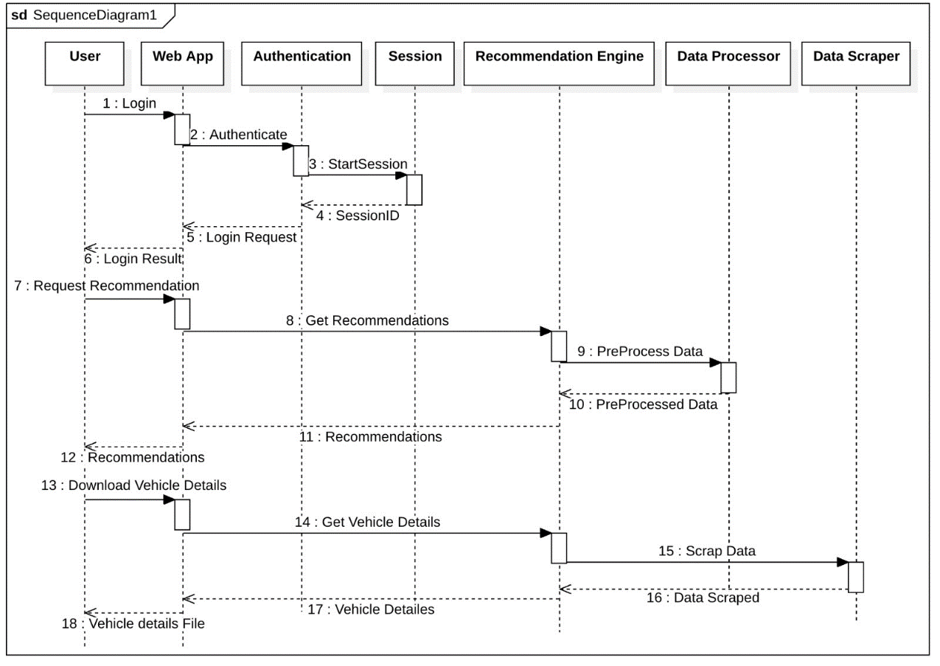

**Fig 3.3.7 Sequence Diagram for AutoRecs**

**Participants:**

1. **User:** The end-user who interacts with the web application to find suitable vehicles.
2. **Web App:** The core functionality of the web application likely built using a framework. It interacts with various services to process user requests and generate recommendations.
3. **Authentication Service:** Handles user login and authentication processes. It verifies user credentials against a database and generates a session ID upon successful login.
4. **Session Manager:** Manages user sessions. It stores session data (e.g., user ID) to identify users throughout their interaction with the application.
5. **Recommendation Engine:** The core service responsible for generating personalized vehicle recommendations. It utilizes user data and vehicle data to find the best matches.
6. **Data Processor:** Responsible for pre-processing data used by the recommendation engine. This may involve handling missing values, encoding categorical data, or normalizing numerical data to improve recommendation quality.
7. **Data Scraper (Optional):** Could be used to scrape vehicle data from external sources, enriching the system with up-to-date information not present in the primary databases.

**Sequence Flow:**

1. **User Login:**

The user interacts with the web app, entering their login credentials (email address and password).

1. **Send Login Request:**

The web app sends a login request to the Authentication Service along with the user's credentials.

1. **Authentication:**

The Authentication Service verifies the user's credentials against a user database (not shown) to determine if the login is valid.

1. **Login Result:**

Based on the authentication process, the Authentication Service responds to the web app with a success message and a session ID if the login is successful, or an error message if it fails.

5. **Session Start (if successful):**

If the login is successful, the web app sends a request to the Session Manager to initiate a user session, including the session ID received from the Authentication Service.

6. **Session Created:**

The Session Manager creates a session for the user, storing session data such as the user ID. It then responds to the web app confirming the session creation.

7. **Request Recommendation:**

With the user session established, the web app allows the user to request vehicle recommendations.

8. **Send Recommendation Request:**

The web app sends a recommendation request to the Recommendation Engine, potentially including the user ID from the session data.

9. **Get Recommendations:**

The Recommendation Engine retrieves relevant user data (e.g., preferences, browsing history) from a user database based on the user ID. It may also fetch vehicle data from a database containing vehicle information.

10. **Pre-process Data :**

The Data Processor may preprocess the user data and vehicle data received from their respective sources.This could involve Handling missing values in the data (e.g., filling missing mileage or price data).Encoding categorical data (e.g., converting vehicle make/model into numerical representations).Normalizing numerical data (e.g., scaling vehicle price or mileage to a standardized range).

11. **Send Recommendations:**

After preprocessing (if applicable), the Recommendation Engine generates personalized recommendations based on the processed data and sends them back to the web app.

12. **Display Recommendations:**

The web app receives the recommendations from the Recommendation Engine and displays them to the user on a web page, facilitating the user's decision-making process.

Integration with Data Processor and Data Scraper (Optional):

**Data Processor**:

* Purpose: Enhances data quality and relevance of recommendations by preprocessing user and vehicle data before recommendation generation.
* Tasks: Handles tasks like data cleaning (handling missing values), data transformation (encoding categorical variables), and data normalization (scaling numerical data).
* Integration: Operates on data retrieved by the Recommendation Engine before generating recommendations, ensuring data readiness and accuracy.
* Data Quality: Data Processor improves recommendation accuracy by standardizing and enhancing the quality of input data.
* Scalability: Both services enable scalability by handling diverse data sources and maintaining system performance under varying loads.

This detailed sequence and integration highlight how each component collaborates to deliver a seamless user experience in finding suitable vehicles through the web application. Each step contributes to ensuring that recommendations are relevant, timely, and aligned with user preferences.

* + 1. **Block Diagram**

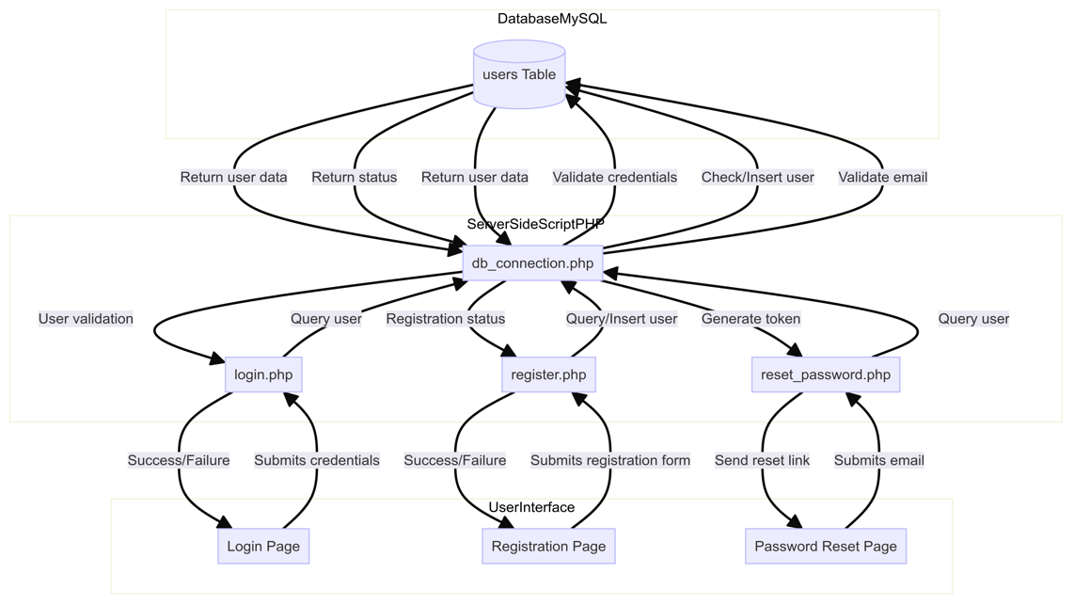

**User Actions:**

* Login
* Register
* Reset password

**Server-Side Scripts:**

* login.php
* register.php
* reset_password.php
* db_connection.php (for database connection)

**Database:**

* MySQL
* users Table

**Server-Side Tasks:**

* User validation
* Check/Insert user
* Validate email
* Generate token
* Query user
* Return user data
* Return status

**User Interface:**

* Login Page
* Registration Page
* Password Reset Page
  + 1. **Flowchart**
* **Start**
* **User Login:** The system initializes and prepares for user interactions
* **Prompt for Credentials:** The system presents a login interface.
* **Validate Credentials:** Checks if the username exists and if the password matches.
* **Decision Point:**
* Yes: Establishes a user session.
* No: Displays an error message for invalid credentials; prompts for re-entry until valid.
* **User Session:** Upon successful login, a session is created to track user activities and preferences.
* **User Request Recommendation:**
  + Prompt for Recommendation Request: Provides an interface for the user to request vehicle recommendations.
* Fetch User Data:Retrieves user preferences, browsing history, and interactions from the system's database.
* **Data Pre-processing:**
* Handles Missing Values: Identifies and manages any missing data in user or vehicle information.
* Encoding Categorical Data: Converts categorical data (like car types or brands) into a suitable format for the recommendation algorithm.
* Normalizing Data: Scales numerical data to ensure fair comparison and algorithm accuracy.
* Scrape Vehicle Data :Gathers latest vehicle information from external sources (e.g., manufacturer websites, dealership listings) and integrates it into the system.
* **Generate Recommendations:** Runs a recommendation algorithm using preprocessed user and vehicle data.Identifies vehicles that best match the user’s preferences, using techniques like collaborative filtering or content-based filtering.
* **Display Recommendations:** Shows recommended vehicles ranked by suitability.Includes details such as make, model, price, features, and possibly images.
* **End:**

This Allows users to explore recommended vehicles further, refine preferences, or continue interacting with the system.This process ensures a personalized and efficient experience for users seeking vehicle recommendations based on their specific preferences and needs.

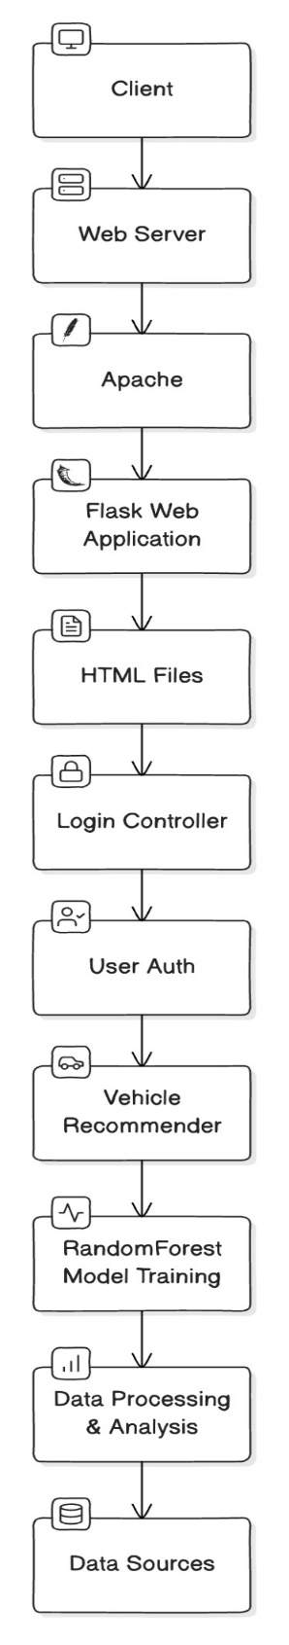

**Fig. 3.3.8 Flowchart for Personalized Vehicle Recommendation System**

**4. PERFORMANCE ANALYSIS**

**4.1 TESTING**

|  |  |  |  |  |  |
| --- | --- | --- | --- | --- | --- |
| Test id | Module name/page | Description | Action | Results | Status |
| Mrslf_T_01 | Home page | Homepage of the website | Display the homepage UI | Test case: pass | Pass |
| Mrslf_T_02 | login page | Show Login pages with difference login details for every module | - | Test case: pass | Pass |
| Mrslf_T_03 | Backend - database | Signup and sign in testing | Run queries | Test case: pass | Pass |
| Mrslf_T_04 | Update database | Update or manage database | Run queries | Test case: pass | Pass |
| Mrslf_T_05 | Dashboard | Dashboard view For Every module | Display the Dashboard UI After login | Test case: pass | Pass |
| Mrslf_T_06 | Logout | Logout from account | - | Test case: pass | Pass |

**A.WEBSITE TESTING**

We perform all the testing related website following Table 4.1 shows all the testing measures-

### Table 4.1 Website testing

### B. Model Accuracy

### 

### Figure 4.1 Accuracy of models

### Accuracy Score

We use testing accuracy as an important metric to evaluate our model’s performance because it shows how the model performs on unseen data that it was not trained on. A test accuracy of 98.5% is very high and indicates that our model is capable of performing well on new data.

### Confusion Matrix

### Confusion Matrix of model

|  |  |
| --- | --- |
| True Positive | False Positive |
| False Negative | True Negative |

### The confusion matrix shows the performance of a car recommendation system in classifying car brands. Each cell represents the percentage of correct predictions (diagonal cells) and misclassifications (off-diagonal cells). The high values along the diagonal indicate that the model accurately predicts the car brand, with most brands achieving over 90% accuracy.

### Definitions:

1. **True Positive (TP)**: The number of correctly predicted positive examples.
2. **False Positive (FP)**: The number of incorrectly predicted positive examples (actual negatives that are incorrectly predicted as positives).
3. **False Negative (FN)**: The number of incorrectly predicted negative examples (actual positives that are incorrectly predicted as negatives).
4. **True Negative (TN)**: The number of correctly predicted negative examples.

### Formulas:

For a given class, let's denote:

* Positive Class=P
* Negative Class=N

#### True Positive (TP):

$TP=∑(Predicted Positive∩Actual Positive)TP=∑(Predicted Positive∩ Actual Positive)$

This is the count of instances that are correctly predicted as positive.

#### False Positive (FP):

$$FP=∑\left(Predicted Positive∩Actual Negative\right)FP$$

This is the count of instances that are incorrectly predicted as positive.

#### False Negative (FN):

$$FN=∑(Predicted Negative∩Actual Positive)FN$$

This is the count of instances that are incorrectly predicted as negative.

#### True Negative (TN):

$$TN=∑(Predicted Negative∩Actual Negative)TN$$

This is the count of instances that are correctly predicted as negative.

1. **RESULTS**

**5.1 Home page**

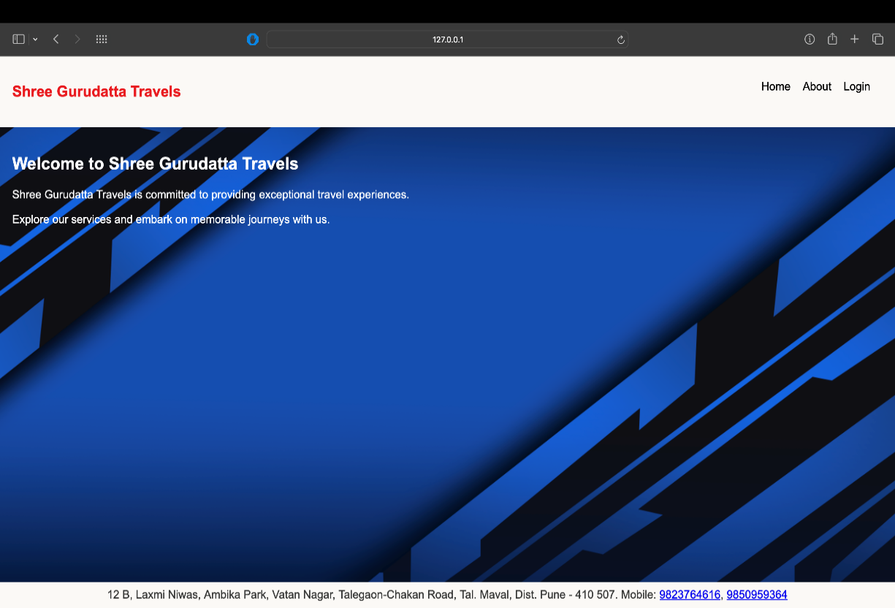

**Fig 5.1. Home page**

**5.2 About Page**

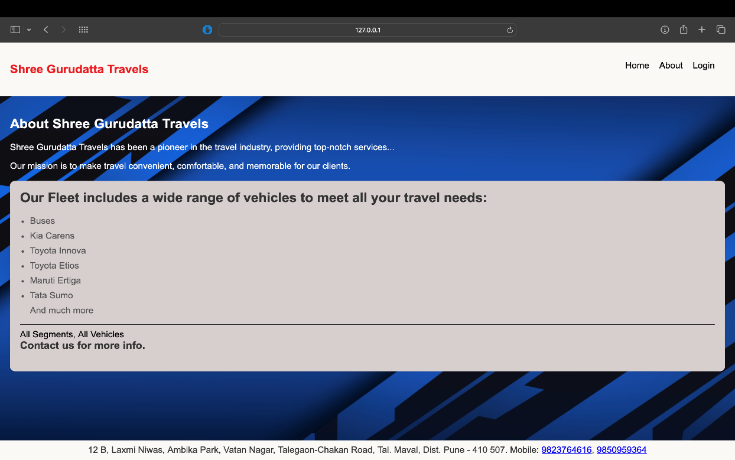

**Fig 5.2. About page**

**5.3 SignUp page**

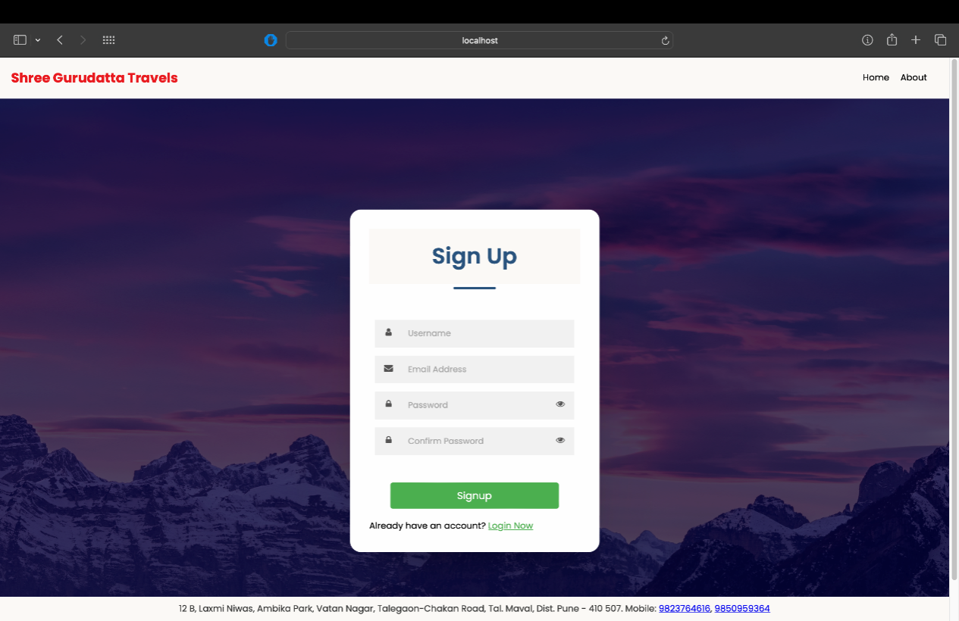

**Fig 5.3 SignUp page**

**5.4 Login page**

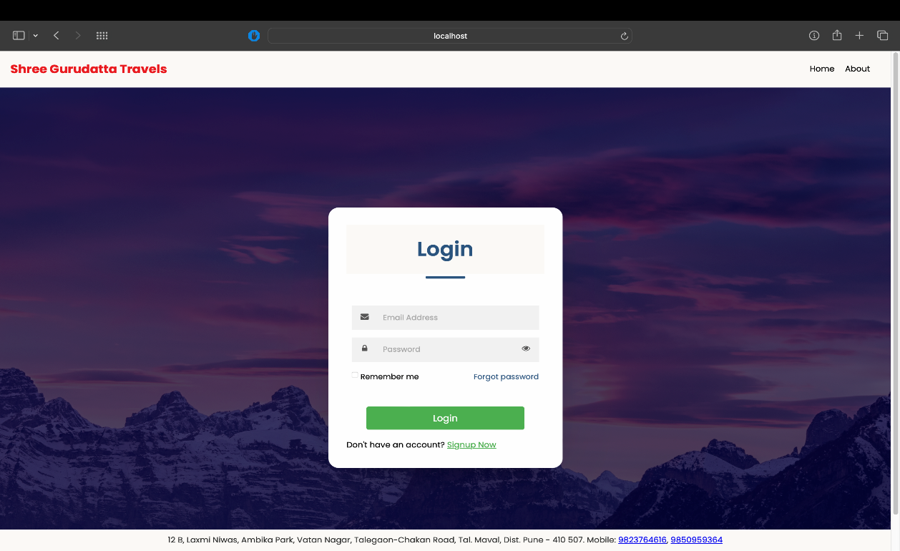

**Fig 5.4 login page**

**5.5 User saved in sql database with encrypted password**

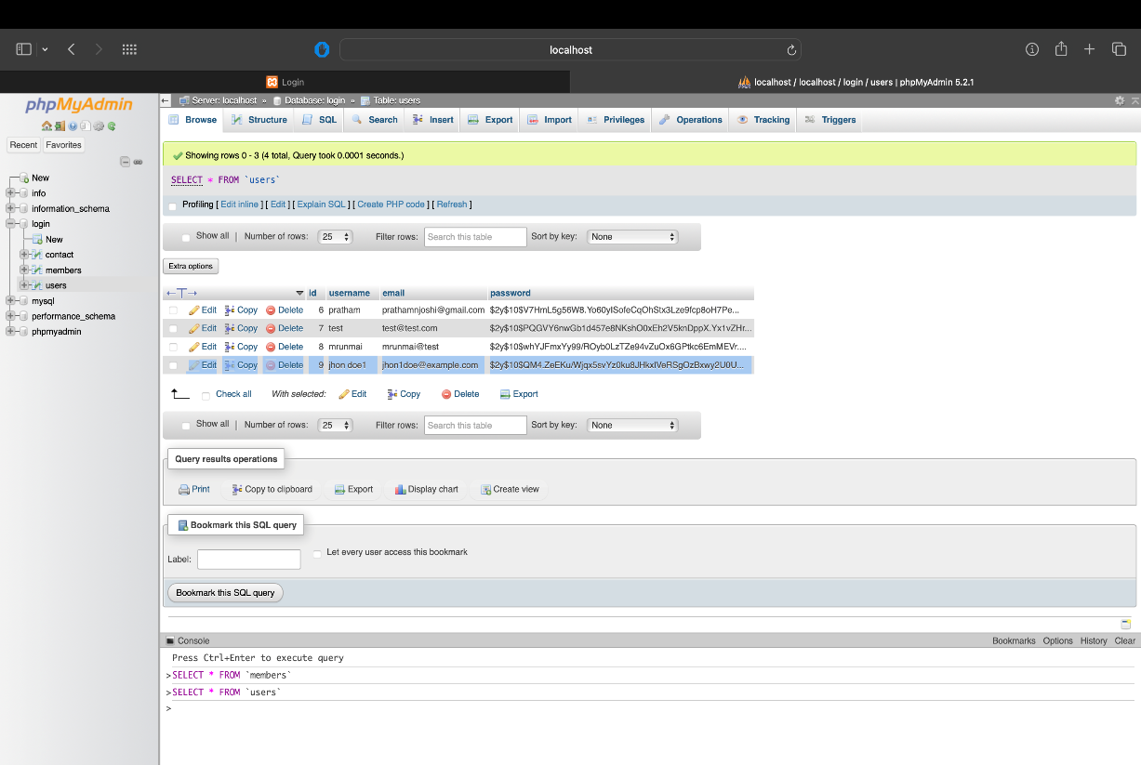

**Fig 5.5 PHP My admin**

**5.6 Prompt for wrong password**

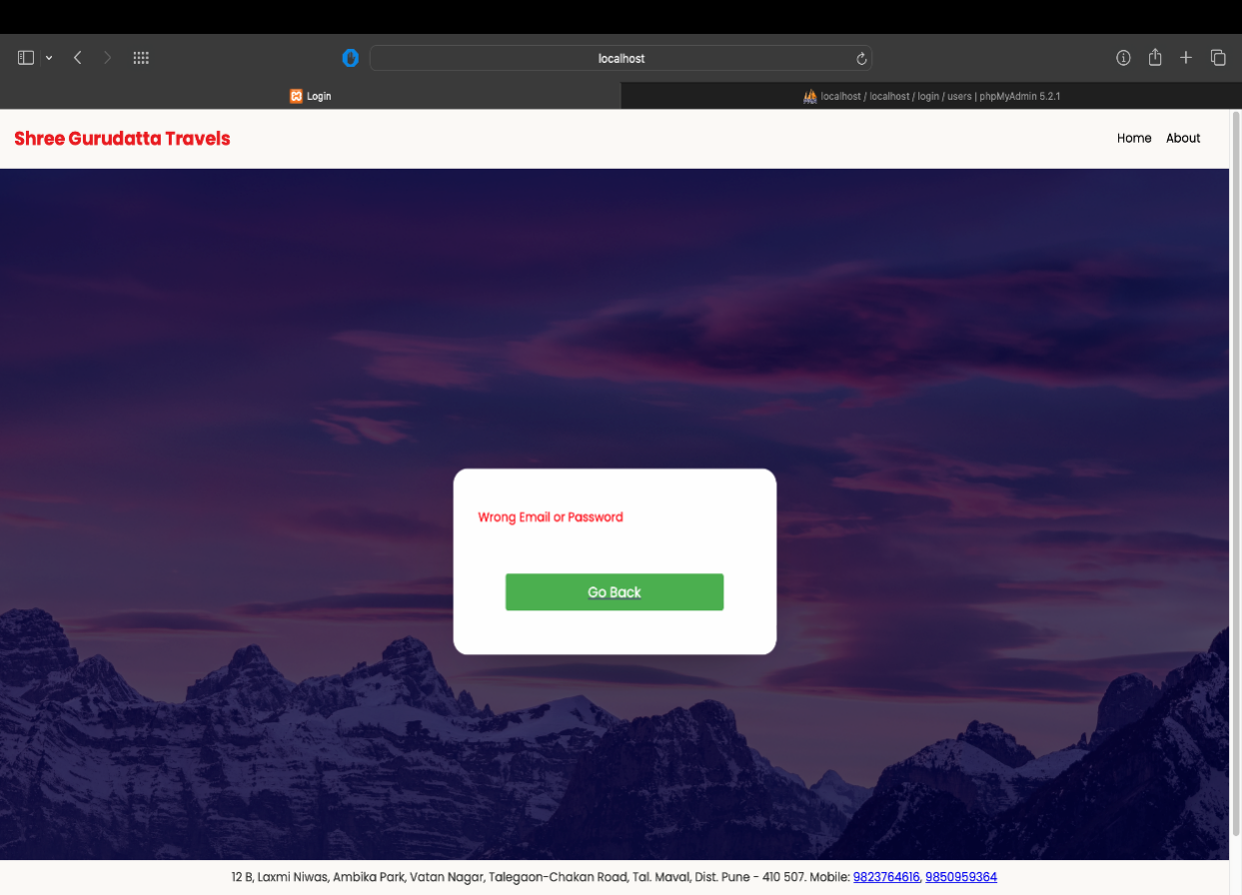

**Fig 5.6 Login error**

**5.7 Vehicle recommender**

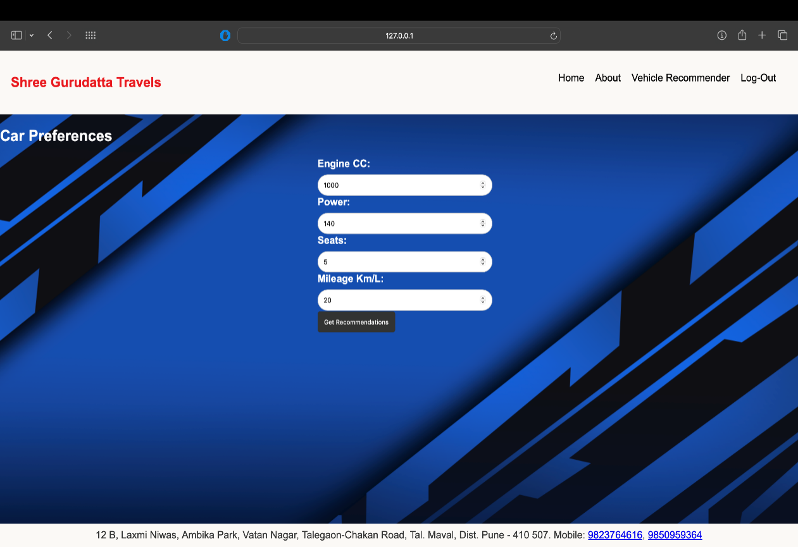

**Fig 5.7 Recommender page**

**5.8 Recommended cars**

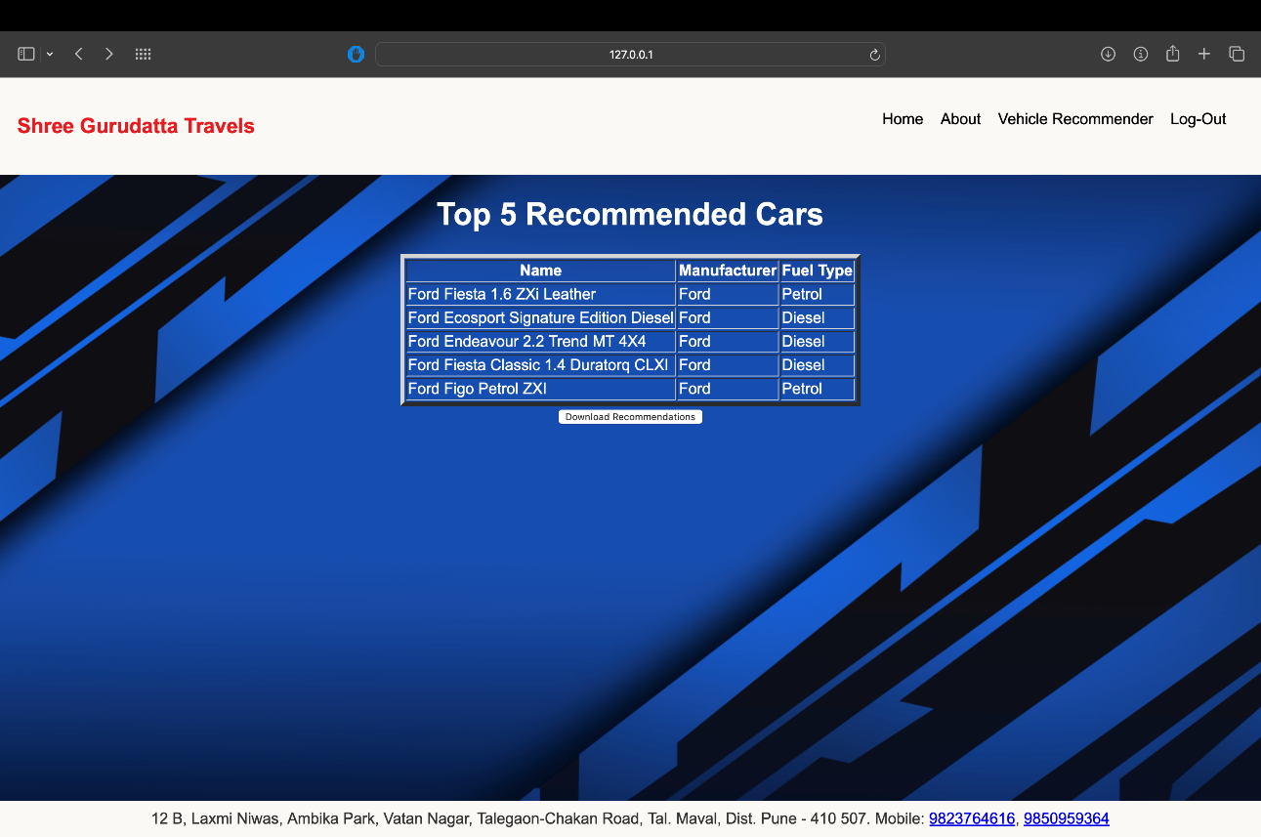

**Fig 5.8 Final Output**

**5.9 Data of what user is trying to get recommendation is appended**

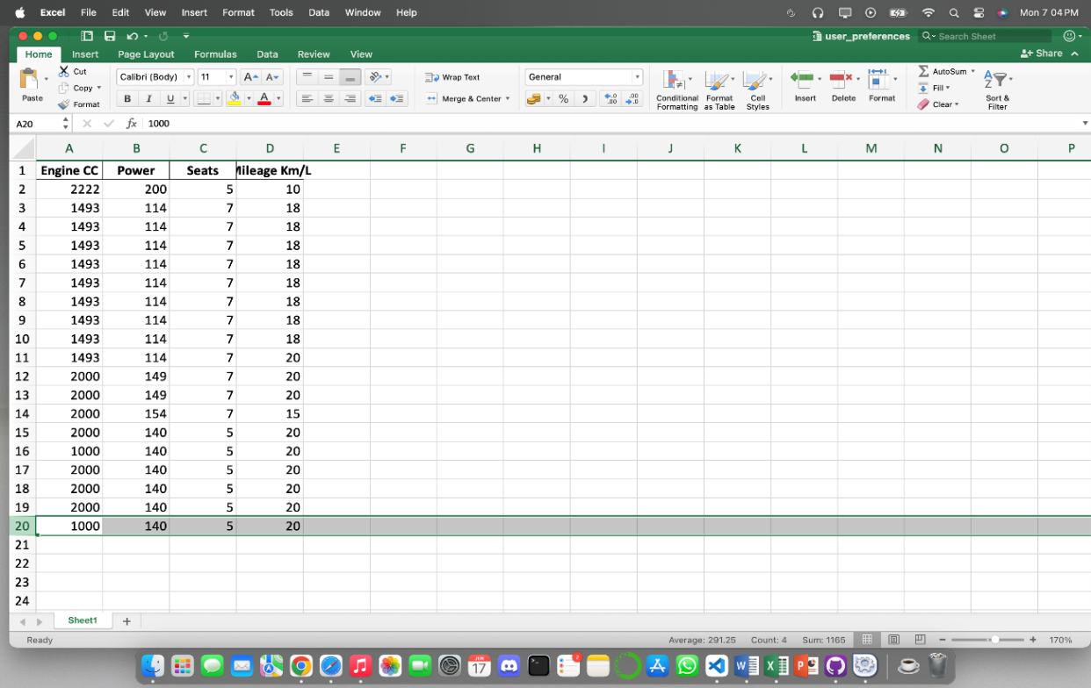

**Fig 5.9**

**5.10 The recommended cars is also saved in a sheet if the user wants they can download it**

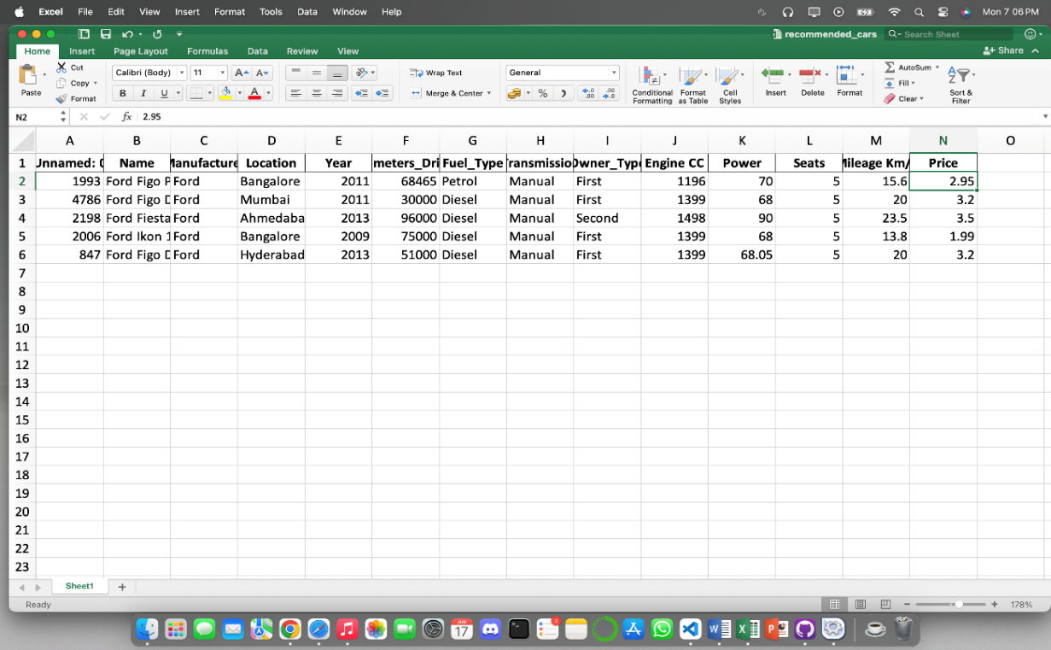

**Fig 5.10**

### CONCLUSION

Car recommendation systems are indispensable in the automotive industry, providing users with dynamic and personalized purchasing insights. This Flask web app, utilizing a Random Forest Regressor model, refines recommendations based on user input, predicting fuel efficiency and suggesting suitable cars. As technology advances, there is a trend towards more sophisticated and user-centric systems, transforming the car-buying process.

As technology continues to advance, car recommendation systems are becoming more sophisticated and user centric. Machine learning algorithms like the Random Forest Regressor used in this app enable accurate predictions and recommendations based on a wide range of data inputs. These advancements not only streamline the car-search process but also ensure that users receive suggestions that align closely with their specific requirements.

The proposed system represents a significant step towards revolutionizing the consumer journey in the digital automotive market. As digital platforms continue to integrate seamlessly, they offer an enhanced and empowering car-buying experience. Users can expect more interactive and personalized interactions with automotive options, which align with their preferences and lifestyle needs. The app's versatility serves as both a search tool and a recommender, while envisioning a future where digital platforms seamlessly integrate, offering an enjoyable and empowering car-buying experience. The proposed system not only embodies current technological capabilities but also sets the stage for a revolutionized consumer journey in the digital real market.

#### 6.1 APPLICATIONS

The Novelty-Driven AutoRecs Personalized Vehicle Recommendation System can be applied in various areas within the automotive industry and beyond. Here are some key applications:

#### 1. ****Online Car Dealerships and Marketplaces-****

* **Enhanced User Experience:** By providing personalized vehicle recommendations that include novel options, online car dealerships can improve user satisfaction and engagement.
* **Increased Sales:** Novelty-driven recommendations can introduce potential buyers to vehicles they might not have considered, thereby increasing the likelihood of purchases.
* **Customer Retention:** Personalized recommendations can help in building long-term relationships with customers by continuously catering to their evolving preferences.

#### 2. ****Automotive Manufacturers-****

* **Market Analysis:** Manufacturers can use the system to understand consumer preferences and trends, helping them in product development and marketing strategies.
* **Inventory Management:** By predicting which models are likely to be popular, manufacturers can better manage production and inventory.
* **Targeted Marketing Campaigns:** The system can assist in designing marketing campaigns that target specific customer segments with tailored vehicle options.

#### 3. ****Car Rental Services****

* **Fleet Optimization:** Rental companies can use personalized recommendations to suggest vehicles that match customer preferences, improving customer satisfaction and loyalty.
* **Customer Insights:** By analyzing customer preferences, rental companies can optimize their fleet composition to better meet demand.
* **Dynamic Pricing:** The system can help in implementing dynamic pricing strategies based on customer preferences and vehicle novelty.

#### 4. ****Financial Institutions (Auto Loans and Insurance)****

* **Risk Assessment:** Personalized recommendations can help financial institutions understand the types of vehicles their customers are interested in, aiding in risk assessment for auto loans and insurance.
* **Customized Offers:** Banks and insurance companies can use the data to offer tailored loan products and insurance policies that match the specific needs of customers.

#### 5. ****Automotive Review and Comparison Websites****

* **Improved Recommendations:** Websites can enhance their recommendation engines with novelty-driven algorithms to offer more personalized and diverse vehicle options.
* **Content Personalization:** By understanding user preferences, these websites can deliver more relevant content, such as reviews and comparison articles.
* **User Engagement:** Novel and diverse recommendations can keep users engaged and encourage repeat visits.

#### 6. ****Consumer Electronics and Smart Assistants****

* **Integration with Smart Devices:** The recommendation system can be integrated with smart home devices and virtual assistants to provide personalized vehicle suggestions directly through these platforms.
* **Voice-Activated Searches:** Users can receive vehicle recommendations via voice commands, making the search process more convenient and interactive.

#### 7. ****Automotive Trade Shows and Events****

* **Personalized Exhibits:** Trade show organizers can use the system to create personalized exhibit experiences for attendees, showcasing vehicles that match their interests.
* **Data Collection:** The system can collect valuable data on attendee preferences, helping organizers tailor future events.

#### 8. ****Mobile Applications****

* **On-the-Go Recommendations:** A mobile app version of the system can provide users with personalized vehicle suggestions anytime, anywhere.
* **Augmented Reality (AR):** Integrating AR features can allow users to visualize recommended vehicles in their environment, enhancing the decision-making process.

#### 9. ****Social Media and Influencer Marketing****

* **Targeted Content:** Influencers and brands can use the system to share vehicle recommendations that are tailored to their followers' preferences.
* **Engagement Campaigns:** Personalized vehicle suggestions can be part of social media campaigns to drive higher engagement and conversion rates.

These applications demonstrate the versatility and potential impact of the Novelty-Driven AutoRecs Personalized Vehicle Recommendation System across various sectors of the automotive industry and related fields.

#### 6.2 FUTURE SCOPE

### I. Integration of Real-time Data-

Enhancing the accuracy and relevance of vehicle recommendations by incorporating dynamic, context-sensitive information.

### Implementation Steps:

1. **Data Sources Identification:**

Identify reliable sources for real-time traffic conditions, weather updates, and road incidents (e.g., APIs from traffic management authorities, weather services, and road safety organizations).

1. **API Integration:**

Integrate APIs from these sources into the recommendation system.Ensure that the system can fetch and process real-time data efficiently.

1. **Data Processing:**

Develop a module to preprocess real-time data (e.g., filtering, cleaning, normalizing).Convert this data into a format that can be used by the recommendation algorithm

.

1. **Algorithm Adjustment:**

Modify the recommendation algorithm to incorporate real-time data as a factor in generating recommendations.Use real-time traffic conditions to suggest vehicles with better fuel efficiency for heavy traffic areas.

1. **Testing and Validation:**

Conduct extensive testing to ensure that real-time data integration improves recommendation accuracy.Validate the system’s performance in various scenarios to ensure reliability.

### User Feedback Integration

#### Purpose:

Creating a feedback loop to continuously improve the recommendation algorithm based on user ratings and feedback.

#### Implementation Steps:

1. **Feedback Collection Interface:**

Design a user-friendly interface for collecting feedback on recommended vehicles.Implement features such as rating scales, comment sections, and survey questions.

1. **Data Storage:**

Store user feedback data securely and ensure it is linked to the respective user sessions and recommendations.

1. **Algorithm Training:**

Develop a mechanism to use collected feedback to continuously train and refine the recommendation algorithm.Implement machine learning techniques to analyze feedback trends and adjust the algorithm accordingly.

1. **Continuous Learning:**

Set up an automated process for the algorithm to learn from new feedback regularly.Ensure that the system adapts to changing user preferences and market trends over time.

1. **Performance Monitoring:**

Monitor the system’s performance and the impact of feedback integration on recommendation accuracy.Adjust the feedback mechanism as needed based on performance metrics and user satisfaction.

### Integration of Voice Assistants

#### Purpose:

Enhancing user experience and accessibility through voice-controlled interfaces using Natural Language Processing (NLP).

#### Implementation Steps:

1. **Voice Recognition System:**
2. Implement a voice recognition system using NLP techniques to understand and process user voice commands.Integrate popular voice assistant platforms (e.g., Google Assistant, Amazon Alexa) if applicable.
3. **Voice Command Processing:**

Develop a module to handle voice commands and convert them into actions within the recommendation system.Ensure that the system can understand various accents, dialects, and languages if necessary.

1. **Accessibility Enhancements:**

Ensure that the voice assistant interface is accessible to users with disabilities.Provide options for voice control in different environments and contexts.

### Predictive Maintenance Recommendations

#### Purpose:

Providing users with recommendations based on the predictive maintenance of vehicles, enhancing reliability and cost-effectiveness.

#### Implementation Steps:

1. **Data Collection:**

Collect historical maintenance data and reliability metrics for various vehicle models. Integrate from manufacturer databases, service centers, and user-reported maintenance logs.

1. **Predictive Analytics:**

Implement predictive analytics models to estimate vehicle reliability and lifespan based on historical data. Use techniques such as regression analysis, machine learning, and time-series forecasting.

1. **Recommendation Algorithm Enhancement:**

Incorporate predictive maintenance data into the recommendation algorithm. Highlight vehicles with lower predicted maintenance costs and higher reliability in recommendations.

1. **User Information:**

Provide detailed information about predicted maintenance and reliability alongside recommendations. Educate users on how predictive maintenance can influence their vehicle choice and ownership costs.

1. **Validation and Continuous Improvement:**

Continuously validate the predictive models against actual maintenance outcomes. Refine the models and algorithm based on new data and user feedback to improve accuracy.

### End-to-End Integration

1. **Unified Interface:**

Develop a seamless user interface that integrates all these enhancements. Ensure that users can easily navigate between real-time data insights, provide feedback, use voice commands, and understand predictive maintenance recommendations.

1. **Backend Coordination:**

Ensure that all data processing, algorithm adjustments, and feedback mechanisms are well-coordinated on the backend. Implement robust data management practices to handle diverse data sources and ensure data integrity.

1. **User Education and Support:**

By implementing these detailed steps, the vehicle recommendation system will be significantly enhanced, offering users more accurate, relevant, and personalized recommendations.

### REFERENCES

* 1. Kavinkumar.V, Rachamalla Rahul Reddy, Rohit P.Covington, J. Adams, and E. Sargin, “Deep neural networksfor youtube recommendations,” Proceedings of the10th 7 ACM Conference on Recommender Systems - RecSys ’16, 2016.
  2. X. Li and J. She, “Collaborative variational autoencoder for recommender systems,” Proceedings of the 23rd ACM SIGKDD International Conference on Knowledge Discovery and Data Mining - KDD ’17, 2017.
  3. Q. Zhang, J. Wang and K. Fan, "Research on passenger car recommendation based on comments mining of Internet," 2017 12th IEEE Conference on Industrial Electronics and Applications (ICIEA), 2017.
  4. Shrey Talati, Anukrity, Priyanka Salian and Anam Hussain. Article: Recommendation System for Automobile Purchasing: A Survey. IJCA Proceedings on National Conference on Advancements in Computer & Information Technology NCACIT 2016(6):23-27, May 2016.
  5. B. Krishnamurthy, N. Puri, and R. Goel, “Learning vector-space representations of items for recommendations using word embedding models,” Procedia Computer Science, vol. 80, pp. 2205–2210, 2016.
  6. J. Wei, J. He, K. Chen, Y. Zhou, and Z. Tang, “Collaborative filtering and deep learning based recommendation system for cold start items,” Expert Systems with Applications, vol. 69, 10 2016.
  7. L. Thomas and V. Vaidhehi, “The design of web based car recommendation system using hybrid recommender algorithm,” International Journal of Engineering Technology, vol. 7, p. 192, 06 2018.
  8. P. Covington, J. Adams, and E. Sargin, “Deep neural networks for youtube recommendations,” Proceedings of the 10th ACM Conference on Recommender Systems - RecSys ’16, 2016.
  9. Basu C, Yang Q, Hungerman D, Sinahal M and Draqan AD Do you want your autonomous car to drive like you? In 2017 12th ACM/ IEEE International Conference on Human- Robot Interaction (HRI), pp. 417-425. IEEE. 2017.

1. Ekman F, Johansson Mand Sochor J Creating appropriate trust for autonomous vehicle systems: a framework for HMI design (no. 16- 3268). 2016.
2. Forster Y, Naujoks F and Neu kum A Increasing anthropomorphism and trust in automated driving functionsby adding speech output. Intelligent Vehicles Symposium(IV), IEEE Press, pp. 365-372. 2017
3. Hasenjager M and Wersing H Personalization in advanced driver assistance systems and autonomous vehicles: a review, IEEE 20th International Conference on Intelligent Transportation Systems (ITSC). 2017.
4. Petersen L, Robert XL, Yang J and Dawn MT Situational awareness, driver’s trust in automated

driving systems and secondary task performance, SAE International Journal of Connected and Autonomous Vehicles. 2019.

1. Ruijten PAM, Terken JMB, Chandramouli SN. Enhancing trust in autonomous vehicles through intelligent user interfaces that mimic human behavior. Multimodal Technol Interact. 2018.
2. Yusof NM, Karjanto J, Terken, J., Delbressine F, HassanMZ and Rauterberg M The exploration of autonomous vehicle driving styles: preferred longitudinal, lateral and vertical accelerations. In Proceedings of the 8th International Conference on Automotive User Interfaces and Interactive Vehicular Applications, pp. 245- 252. ACM. 2016.
3. F. S. Gohari, F. S. Aliee and H. Haghighi, “A trust-aware group recommender system using particles warn optimization,” International Symposium on Computer Science and Software Engineering Conference(CSSE),Shiraz, pp. 80-85, 2017.
4. B. K. Sunny, P. S. Janardhanan, A. B. Francis and R. Murali, “Implementation of a self-adaptive real time recommendation system using spark machine learning libraries,” IEEE International Conference on Signal Processing, Informatics, Communication and Energy Systems (SPICES), Kollam, pp. 1-7, 2017.
5. V. B. Savadekar and M. E. Patil, “Improved recommendation system with review analysis,” International Conference on Global Trends in Signal Processing, Information Computing and Communication (ICGTSPICC), Jalgaon, pp. 79-82, 2016.
6. H. L. Nguyen and J. J. Jung, “Utilizing Dynamics Patterns of Trust for Recommendation System,” International Conference on Intelligent Environments (IE), Seoul, pp. 108- 113, 2017.
7. Zhang and Xiaoying, “Modeling the Assimilation Contrast Effects in Online Product Rating Systems: Debiasing and Recommendations,” Proceedings of the Eleventh ACM Conference on Recommender Systems, pp. 98-106, 2017.
8. Evangelia Christa kopoulou and George Karypis, “Local Item-Item Models for Top-N Recommendation,” Proceedings of the 10th ACM Conference on Recommender Systems, pp. 67-74, 2016.
9. Xiaoming Liu, Chao Shen, “We know who you are: Discovering similar groups across multiple social networks,” accepted for inclusion in IEEE Transactions on Systems, Man and Cybernetics Systems, 2018.
10. Surong Yan, Kwei-Jay Lin, Xiaolin Zheng and Xiaoqing Feng, “An approach for building efficient and accurate social recommender systems using individual relationship networks”, IEEE Transactions on Knowledge and Data Engineering, Vol. 29(10), October 2017.
11. Xiwang Yang, Chao Liang, Miao Zhao, Hongwei Wang, Hao Ding, Yong Liu, Yang Li and Junlin Zhang, “Collaborative filtering based recommendation of online social voting”, IEEE Transactions on Computational Social Systems, Vol. 4(1), March 2017.
12. Anitha Anandhan, Liyana shuib, Maizatul Akmar Ismail, and Ghulam Mujtaba, “Social Media Recommender Systems: Review and Open Research Issues,” In IEEE Access, April2018.
13. Ningning Yi, Chunfang Li, Xin Feng, Minyong Shi, “Design and Implementation of Movie Recommender System Based on Graph Database,” 14th Web Information Systems and Applications Conference, 2017.

**ANNEXURE 1**

**SPONSORSHIP LETTER**



**ANNEXURE 2**

**Response Mail**

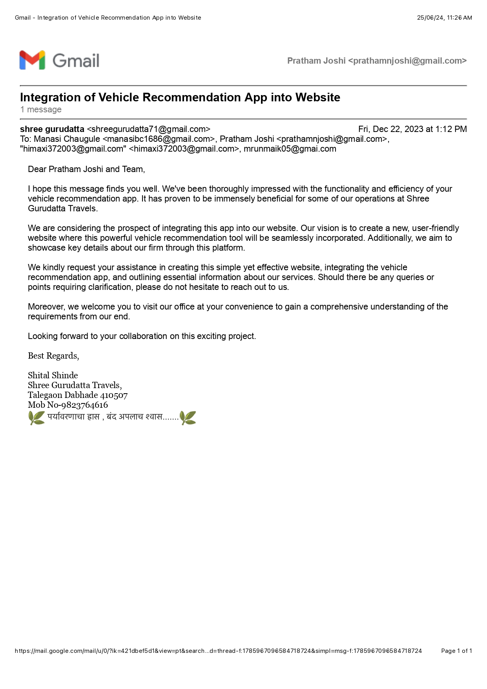

**ANNEXURE 3**

**PAPER PUBLISHED**

